Science
Uses of Materials
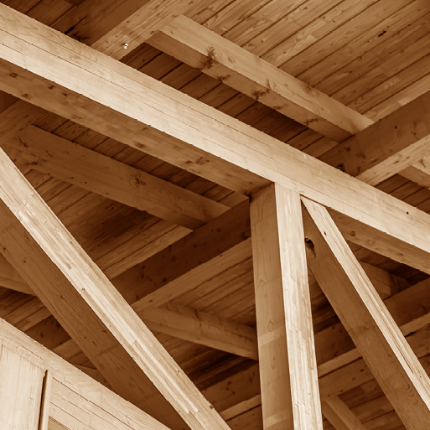
Plant Survival
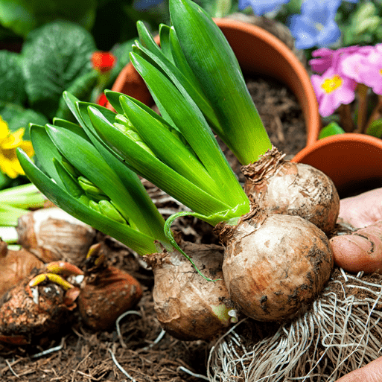

RE
Islam: What is important for Muslim families?
Why do Christians call Jesus ‘Saviour’?

DT
Cut, Stitch and Join
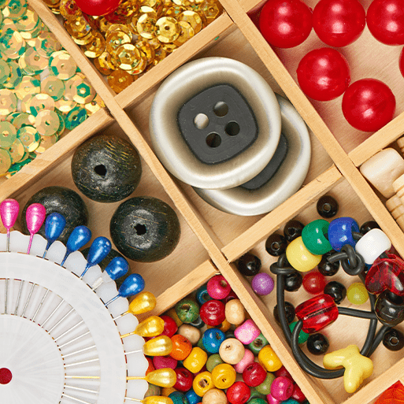
English
- The Three Billy Goats Gruff
- Instruction Writing
-Grammar
-Information Text

Maths
- Money
- Multiplication & Division
- Length & Height
- Mass, Capacity & Temperature

Computing
- Making Music
- Data and Information: Pictograms
Music
- Contrasting Dynamics
- Singing ‘On this Island’
Art
Portraits and Poses
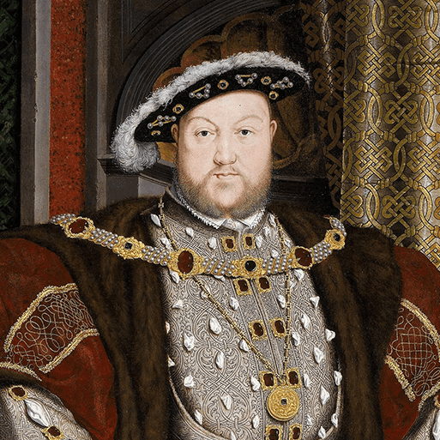
Year 2
Magnificent Monarchs
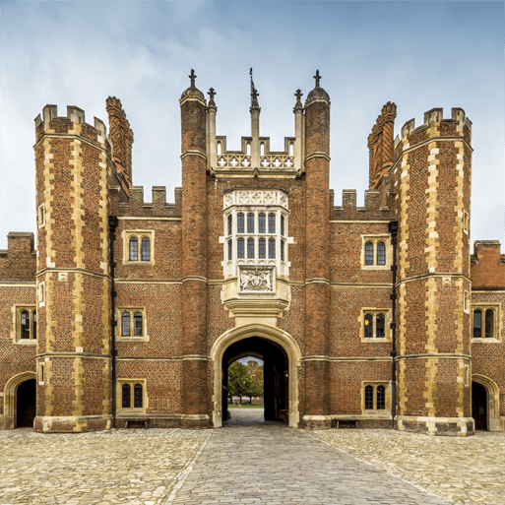

History
Meet the Monarchs
Six Significant Sovereigns
PSHE
Dreams & Goals
Healthy Me
PE
Games
Gymnastics
Dance

Can you find any of these books in your local library?
Paddington at the Palace
Katie in London
Does The Queen Wear Her Crown in Bed?
Rex and the Crown Jewels Robbery
Rex and Princess Victoria
Queen Victoria's Knickers
The Queen's Hat
Daisy Saves the Day
The Royal Nappy
The Cook and the King
Small Knight and George
Ron the Royal Guard
The Kiss That Missed
Any non-fiction books about kings and queens
Challenges:
Use Google Maps to find as many Royal Residencies as you can
Using chalk on a pavement, draw a timeline of significant British monarchs

Suggested Home Learning

Places to visit:
Hampton Court
Buckingham Palace
The Tower of London

Programmes to watch:
Horrible Histories Monarchs song - https://www.youtube.com/watch?v=vC6okzIKQvg
BBC Bitesize – Monarchs and Leaders https://www.bbc.co.uk/bitesize/topics/zkrkscw
For more information visit the Curriculum page on our website: https://www.stgiles.surrey.sch.uk/curriculum/
Stick me on your fridge!

